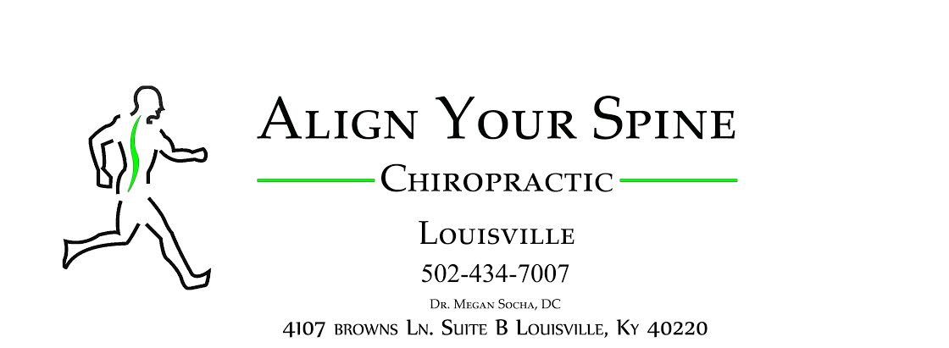
Welcome To Wellness Certificate
Includes:
Detailed Health History
Spinal and Postural Assessment
Range of Motion Testing
Surface EMG and Thermal Nerve Scans
30-minute Nutritional Guide Consultation

$57.00 ($185 value)

You have the right to rescind within 72-hours any obligation to pay
For services performed in addition to the fee.

Offer not valid for those eligible or currently enrolled in Medicare due to Medicare rules and regulations

4107 Browns Lane, Suite B, Louisville, KY 40220-Phone (502)434-7007-Fax (844) 729-1988-ayslouisville.com

